
The Food Pantry is open on:
Monday’s 3:00-5:00 PM
Friday’s 1:00-3:00 PM

Volunteers Needed. Please contact Jennifer Stafford @ (828) 455-8277 or jennstafford3@gmail.com if you are interested.

Special Needs: Peanut Butter, Jelly, Rice, Dry Beans, Spaghetti Sauce, Spaghetti & Shampoo.
~~~~~~~~~~~~~~~~~~~~~~~~~~~~~~~~~~~~~~~~~~~~

G.L.O.W.

Glorify God, Spread Love,
Overwhelm with Joy & Witness to Others.
Our mission is to make and distribute care packages to those battling cancer in hopes of bringing joy and spreading God’s Love.

You can nominate someone by filling out a card with the requested information and place in the G.L.O.W. box located in the Narthex. Care Package/Prayer Shawl requests will be picked up from the box each Sunday. Someone from our ministry will be in contact about your request.
Want to help? Any donations towards our ministry are greatly appreciated.

See Laura Barnes or Olivia Stillwell.
~~~~~~~~~~~~~~~~~~~~~~~~~~~~~~

Please donate the following items for foster families:
Baby wipes, Dreft baby detergent, baby wash, and baby lotion. The baskets are in the narthex
Financial donations: make check payable to “ACFPA”


On Sunday, October 25th
we began assisting our Mt. Pisgah Food Pantry by providing
Thanksgiving Meal Kits.

(Please return the bag by Fri. Nov. 13th)

The list and sign-up sheet will be available in the narthex. Take a bag – sign your name on the sheet with the matching number – bag the items on the list – return the bag to the church by Friday, Nov. 13th
Donations are also welcome.
Turkey’s & bags will then be distributed to our Food Pantry families on Nov. 17th & 19th

Contact the church office, Jennifer Stafford or Debbie Kafer for more information.
~~~~~~~~~~~~~~~~~~~~~~~~~~~~~~~~~~~~~~~
Angel Trees are Coming!

Two Angel Trees will be placed in the Narthex during the month of December. Children in Foster Care in Alexander County will be represented. The need is great again this year so please help to fulfill the Christmas wish of each child. A sign-up sheet and instructions for returning the gifts(s) will be posted by the trees. You may get your Angel on Sunday 11/22 and will need to return the gifts by Monday 12/14. Watch for more details.

Thank you for making the Christmas wishes of a child come true.
The Outreach Committee
Alexander County Foster Parent Association


Boy Scouts meet
on Tuesday(s)
6:00-8:00 PM
~~~~~~~~~~~~~~~~~~~~~~~~~~~~~~~~~~~~~~~~~~~~~~~~~~~~~~~~~~~~

Book Club
2026

The book club will hold its last meeting of the year on Saturday, November 21, at 9:00 am at the church. We will be discussing Under a Gilded Moon by Joy Jordan-Lake; Vicki Boyd will lead our discussion. Please remember to send Barb Beck (ahbbjb@aol.com) your suggestions for books to discuss in 2027.

As always, book club is open to any women of the church and their friends. We welcome new members.
~~~~~~~~~~~~~~~~~~~~~~~~~~~~~~~~~~~~~~

Please join us Sunday, November 1st for a Preview of Episode 1, Season 6 of “The Chosen”, at 12:30 PM. Lunch will be provided before the movie at 11:30 AM.
Please sign up if you would like to join us for lunch.
~~~~~~~~~~~~~~~~~~~~~~~~~~~~~~~~~~~~~~~~~~
Lumos Candlelight Concert
Experience the music of The Beatles by candlelight at Mt. Pisgah Lutheran Church on Saturday, November 7th. We will see you at the 6 PM or 8 PM show if you were lucky enough to get tickets.
Tickets are sold out for this event.

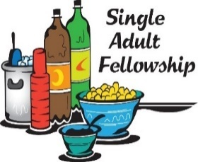
Join us for lunch on Thursday, November 19 at 11:15 am at Hughes Q, which is located at 2117 US Hwy. 70 SE. Hughes Q is known for all types of BBQ, but they also serve delicious Southern comfort food favorites including green bean casserole, fried okra, and mac and cheese. This group is open to any singles, both men and women!

A driving tip: If you take MacDonald Parkway to Hwy. 70 and turn right, you'll be on the correct side of the road to turn into the restaurant's parking lot. Questions? Call or text Janice Simmons at 828-850-5920 or Barb Beck at 630-951-0620.
~~~~~~~~~~~~~~~~~~~~~~~~~~~~~~~~

America250 Veterans Day Celebration
Come enjoy a special history presentation of the bravery of Alexander County veterans, special music from two musical groups, and a reception on Saturday, November 14, at 3:00 p.m. at Bethlehem Baptist Church. Our own Warren Hollar will be the presenter.
~~~~~~~~~~~~~~~~~~~~~~~~~~~~~~~~

✨⭐ 50th BETHLEHEM STARLIGHTING ⭐✨
Join us for a beautiful evening as we gather to celebrate the beginning of the Christmas season!
📅 Saturday, December 5th
🎶 Special Music – 6:00 PM
🌟 Bethlehem Starlighting – 7:00 PM
Bring your family and friends and join us for this special Christmas tradition! ❤️🎄
Musical presentations will include ACHS students, the Pisgah Ringers, and more. Come enjoy music, bonfire, hot chocolate, a live manger scene and the lighting of the star ushering in the Christmas Season in Bethlehem.
Come celebrate the Light of Christmas with us! ✨

Women’s Bible Study is on Wednesdays,
At 10:00 a.m. and 6:00 p.m.
The current study book is “The Names of God.”
Reach out to Yvonne Osborne
for more information (828-302-1145).
~~~~~~~~~~~~~~~~~~~~~~~~~~~~~~~
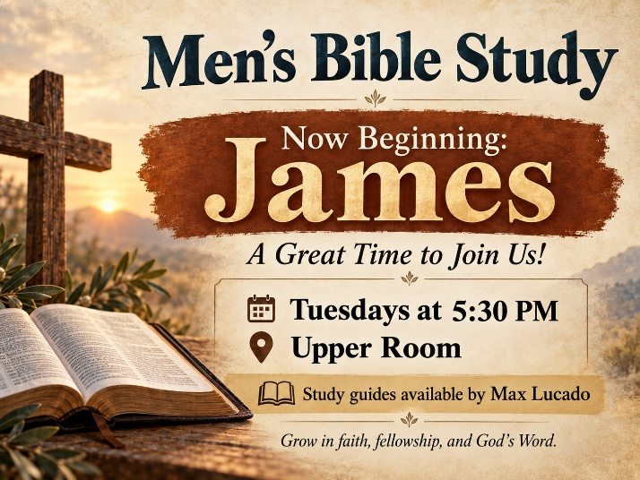
Men’s Bible Study: A Great Time to Join Us!
Our Men’s Bible Study group recently completed our journey through the book of Revelation, and we are excited to begin a new study of the book of James!
James offers practical wisdom for living out our Christian faith in everyday life, reminding us that faith is more than just what we believe. It is reflected in how we live, speak, and treat others.
This is a great time to join us! Whether you are new to Bible study or have been studying Scripture for years, all men are welcome. We enjoy meaningful discussions, fellowship, laughter, and opportunities to grow together in faith.
We meet every Tuesday at 5:30 PM in the Upper Room. Study guides by Max Lucado are available to help guide our discussions.
We would love to have you join us!

Sandy Hefner and family on the death of Don Hefner, Rosco Troutman, Konner & Richelle Soderberg (missionary support), Hugh Stafford, Maverick (son of Josh & Kasie Hughes), Tim & Lynn Wilson, Shirley Patterson (mother of Steve Talley), Carolyn Carpenter, Bob Setzer (brother of Tressa Cline), Sue Heavner, Alice Kirby, Nancy Hendron, Richard Wright, Bill Oelkers, Graham Thick ), Kyle Setzer, and Dwight Fitzgerald.

Shut Ins: Arlene Bolick, Denise Conklin, Dwight Helton, Ronald Johnston, Sandy Moore, Sandy Rose, Darrell Sigmon, Martha Eggers & Ruth Harkey.
````````````````````````````````````````````````````````````````````

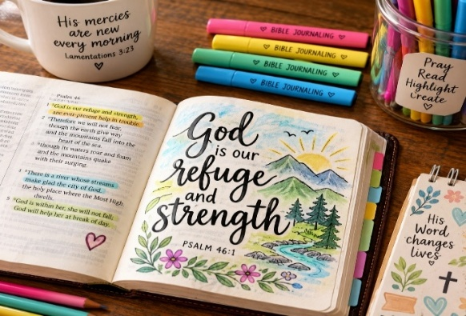

Join us for “Bible Journailing” on Tuesday’s @ 6:30 PM (downstairs in the KIC room) for a fun filled session of combining scripture and creativity for a deeper connection with
God’s Word.
No Crafting or artistic skills required!
Childcare provided!
For more information contact:
Laura Barnes @ 828-855-4396



Two of our adult Sunday School classes are studying Francis Chan’s book and video series, Letters to the Church.

Chan challenges Christians to consider what the Church is called to be and how we can live more faithfully as the body of Christ. Through Scripture, video teaching, discussion, and reflection, we’ll explore what it means to be a Christ-centered community marked by love, prayer, discipleship, and a passion for God’s mission.

You are invited to join either class, any time!:

YAHSS – Young at Heart Sunday School
Meets in the Upper Room

Adult Sunday School with Yvonne Osborne
Meets in Celebration Hall

Come study with us as we ask an important question: What does Jesus desire for His Church, and how can we faithfully live that out together?
~~~~~~~~~~~~~~~~~~~~~~~~~~~~~~~~~~~~~~

Join us for Faith and Fitness, Tuesdays from 5:20 to 6:00 PM in the Celebration Hall.
Contact Yvonne Osbone with any questions (828) 302-1145
(There will be
no classes on 11/24, 12/22 & 12/29)



Calling all young adults, 20 to 40ish, to join us Sundays at 9:15 AM, where we will gather in the Welcome center. Bring a friend. We’ll have real conversations about faith and life. We will relax, drink coffee, and enjoy meaningful discussions.
~~~~~~~~~~~~~~~~~~~~~~~~~~~~~~~~~~~~
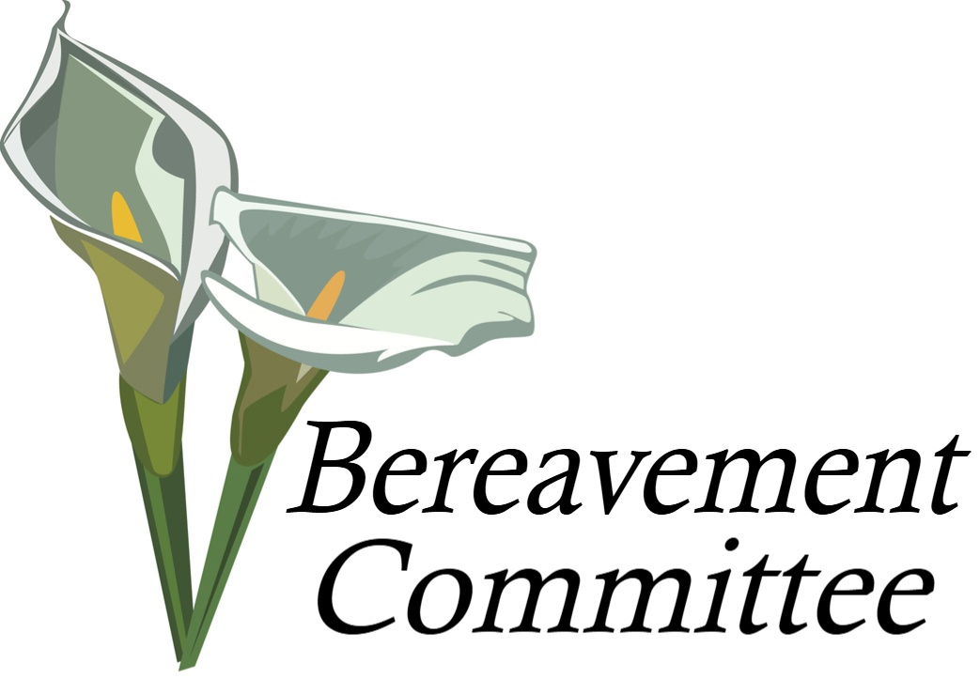
Mt. Pisgah Bereavement Committee

Mt. Pisgah’s Bereavement Team supports families during the loss of a loved one by providing meals, flowers, and other needs as they arise.

If you would like to join this ministry of care and compassion, please contact Yvonne Osborne at 828-302-1145.
~~~~~~~~~~~~~~~~~~~~~~~~~~~~~~~

There are many musical opportunities for those who are interested. The Choir meets Wednesdays at

7:00 PM and Handbell practice is Sundays at 5:00 PM. We’d love to have you join us.



Wednesday night Youth
Through November 18th
Dinner at 5:15 PM
Youth at 6:30 PM

Sunday, Nov. 8th – Youth Sunday

Friday, Nov 14 th – 6:00 Youth Friendsgiving @
Mt. Pisgah
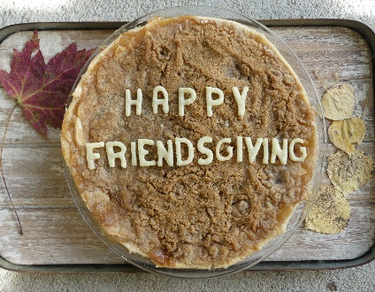

Friday, Dec. 18th – Youth Christmas Caroling &
Dinner/Party to follow



Please see Josh & Stephanie Davis if you have questions or send an email to: stephanieh.davis2008@gmail.com

Also, check our Facebook page for updates. We are blessed!

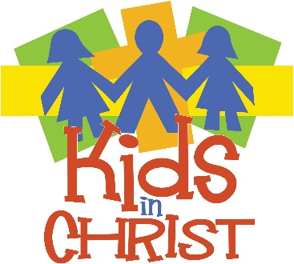

Join us for our KIC Wednesday night activities (through Nov. 18th)
Dinner @ 5:15 PM
KIC activities 6:15–7:30 PM
~~~~~~~~~~~~
Join us for Sunday school every Sunday morning from 9:15–10:15 AM
We always have a blast!
See you there!
~~~~~~~~~~~~~
Mark your calendars:

Sunday, Nov. 15th - Children Sing during
10:00 AM Worship Service

Sunday, Nov. 22nd – 1-3:00 PM, Skating at Skylite Skating Rink

Friday, Dec. 4th – (6-9:00 PM) KIC Pajama Party

Wednesday’s Dec. 2nd, 9th, & 16th – We will be practicing for our Christmas program, 5:40-6:10 PM (Send your child to the Upper Room upon finishing dinner)

Saturday, Dec. 5^{th,} 12^{th, &} 19th – (9-11:00 AM)
Children’s Christmas Program Practice


Sunday, Dec. 20th – Children’s Christmas Program
(9:00 Breakfast & One 10:00
AM Service)

Children’s Program practice has begun! Please see Kelcie if you have not received your part or music for the program.

Please join our Facebook page for updates & more info: Mt. Pisgah Lutheran Church
Kids in Christ OR email: KIC@mtpisgahelca.orgto reach Lindsay

A huge thank you to everyone who volunteered during our Fall Festival—what an amazing, God-filled day it was! Thank you for bringing joy and energy throughout our day in serving our Bethlehem community.

And thanks to everyone who showed up to help clean and declutter the church. Everything looks Great!!

Also, a big shout out and thank you to everyone who made Reformation/Homecoming service such a special Sunday of music, food & fellowship. All of your hard work made for a very special day!

Lastly, none of this would have been possible without your prayers and donations! We are Truly “Blessed to be a Blessing” and it shows!
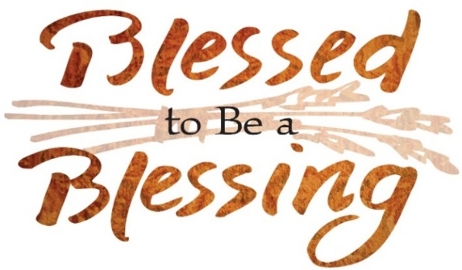
‘‘‘‘‘‘‘‘‘‘‘‘‘‘‘‘‘‘‘‘‘‘‘‘‘‘‘‘‘‘‘‘‘‘‘‘‘‘‘‘‘‘‘‘‘‘‘‘‘‘‘‘‘‘‘‘‘‘‘‘‘


Would you like to become more involved in the church? We have 2 opportunities for you to help.

Please prayerfully consider becoming an Usher or a Lay Assistant during 2027.

Our signup sheet(s) will be available in the late November/December bulletins.

We are grateful for you and your willingness to serve our church family!

Please contact Yvonne Osborne if you have any questions at (828) 302-1145

Sun. Nov.29th–First Sunday of Advent
Wed. Dec. 2nd –5:15-6:15 PM Advent Meal
5:40-6:10 Children’s Play Pract.
6:15 PM Advent Worship
7:00 PM Choir/Cantata Practice
Fri. Dec. 4th – 6-9:00 PM KIC Pajama Party
Sat. Dec. 5th – 9-11 AM Christmas Play Pract.
6:00 PM Bethlehem Starlighting
Sun. Dec. 6th – Second Sunday of Advent
Wed. Dec. 9th - 5:15-6:15 PM Advent Meal
5:40-6:10 Children’s Play Pract.
6:15 PM Advent Worship
7:00 PM Choir/Cantata Pract.
Sat. Dec. 12th – 9-11AM Christmas Play Pract.
Sun. Dec. 13th –Third Sunday of Advent
10:00 AM ONE Service w/
Choir Cantata & Handbells
Wed. Dec. 16th–5:15-6:15 PM Advent Meal
5:40-6:10 Children’s Play Pract
6:15 PM Advent Worship
7:00 PM Choir/Cantata Pract.
Fri. Dec. 18th – 6:00 PM Youth Christmas
Caroling & Dinner
Sat. Dec. 19th - 9-11 AM Children’s Program
Final Practice & Dress Rehearsal
Sun. Dec. 20th –Fourth Sunday of Advent
9:00 AM Men’s Group serving
Hot Breakfast for Everyone!
10:00 AM ONE Service /with
Children’s Christmas Program
Thurs. Dec. 24th–5:00 PM Contemporary &
7:00 PM Traditional Christmas
Eve Candlelight service(s)
Friday, December 25th
MERRY CHRISTMAS!
Nurturing Faith Across Generations: Christian Education Year Ahead
The Christian Education Committee is excited to share our goals and initiatives for this ministry year as we work together to nurture faith at every stage of life:
- Unified Faith Learning: We are aligning our Sunday School and Bible Study curricula with Pastor Justin’s sermon series so families can share connected faith conversations at home. In partnership with Outreach, we are also considering some specialty class offerings on topics such as Financial Literacy, Grief, Effective Leadership, and Marriage.
- Young Adult Ministry (Ages 19–25): We are creating intentional spaces for recent high school graduates and young adults to stay connected, featuring casual fellowship opportunities during breaks and holidays. The process began with a voice of the congregation session with this specific demographic to get ideas on how best to support them.
- Youth & KIC (Kids in Christ) Focus: Youth groups (6th–12th grade) are being structured for deeper, maturity-appropriate discussions. We are working to develop pathways for students to get the general message as a whole group, but then separate out for deeper discussions, which will include opportunities for students and their families to select which pathway would best suit their needs. Plus, our 5th–7th graders are preparing for Lutheridge this summer, while 8th–12th graders look ahead to the National Youth Gathering.
- Active Worship Leadership: Youth and KIC will take on hands-on leadership roles during liturgy on Youth Sundays—sharing prayers, multi-generational reflections, and joint service projects.
- Confirmation & Leadership Safety: We are enriching our Confirmation curriculum and requiring Safe Gathering Training for committee leaders and volunteers.

Treasury Report 10/22/26
Income for August was $32,955, which is 88% of budget and income for September was $24,186 which is 64% of budget. Expenses for August were $37,791 which is 101% of budget and expenses for September were $35,791 which is 95% of budget.
So, for August and September we spent $16,441more than we received. Year to date through September we have spent $19,088 more than we received.
This is not a great way to start the year, but I have faith that things will turn around. We have $146,092 in the reserve account as of September 30th.
As I have said before, we really need as many people as possible to increase their regular giving. As everyone is aware, expenses are not likely to go down. I am confident that giving will improve over the next few months.
Feel free to reach out with any questions you have, and I will do my best to answer them.
Noelle Bernesser
Treasurer
~~~~~~~~~~~~~~~~~~~~~~~~~~~~~~~~~~~~~~~

With just a few clicks, you can set up your gift today!

Scan the QR code provided to go directly to the giving form and support the work of the Church. If you have any questions or need any assistance setting up online giving you may contact Donovan Douglas.


Join Us for a Special “Christ
The King/Thanksgiving” Worship & Meal

Gather together on Sunday, November 15th for One Worship Service at 10:00 AM as we celebrate Thanksgiving in worship and fellowship.

After the service, we’ll share a Covered Dish Thanksgiving Meal together. Turkey and Ham will be provided — please bring a hearty dish to share as we enjoy this special time of gratitude and fellowship. A signup will be in the Narthex to ensure a good variety.

Let’s give thanks together for God’s blessings and the joy of our church family!
~~~~~~~~~~~~~~~~~~~~~~~~~~~~~~~~~~~

Calling thespians, singers, musicians, and set designers of all ages. The children need our help to have the best Christmas program ever!

Look for the opportunity to participate in the very near future.
You can reach out to Kelcie Bagley if you want to help.
Family Coloring Fun!

~~~~~~~~~~~~~~~~~~~~~~~~~~~~~~~~~~~~

Remember the
Bethlehem Farmer’s Market will be on
Thursday’s from 4 to 7:00 PM
November 5th and 12th

~~~~~~~~~~~~~~~~~~~~~~~~~~~~~~~~~~~~~~~~~~~~~~~~~~~~~~~~~
 We will be collecting hats and gloves for children and adults from Monday 11/2/26 through Saturday 2/27/26
Look for more information to follow.

